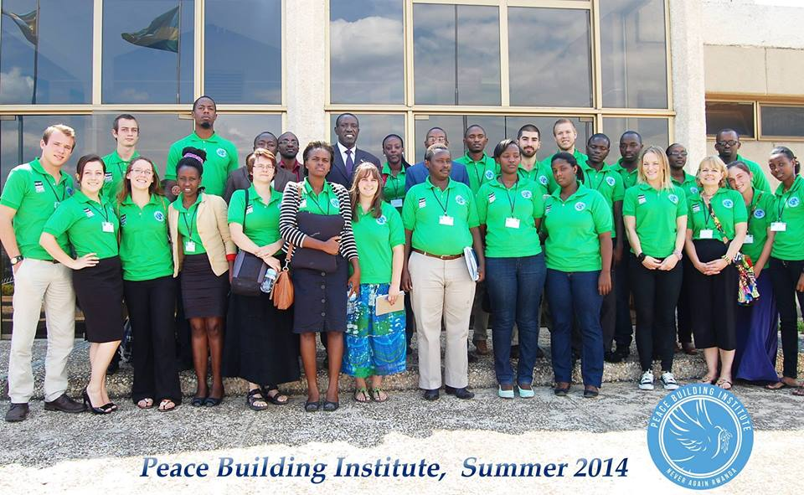

Weber State University
POLS 2930: Peacebuilding in Rwanda
Summer 2015

Professor: Dr. Stephanie Wolfe
Class Meetings: Online Modules prior to departure, May 14th –May 31st Institute
Office: Social and Behavioral Sciences 296
Office Hours: By Appointment
E-mail: stephaniewolfe@weber.edu
Phone: Skype – dr.stephanie.wolfe
OVERVIEW
At the completion of the Peacebuilding Institute, students will be able to:

- Describe Rwandan history, culture, and society from the legal, political, and sociological aspects.
- Understand the history of the Rwandan war and genocide.
- Understand, evaluate, and discuss Rwanda’s efforts towards peace, democracy, and reconciliation.
- Understand how to prepare for work in peace building and human rights advocacy.
- Synthesize knowledge derived from theory, research, participant observation, and service work for a comprehensive understanding of Rwandan society.
In this course, students will travel to Rwanda to participate in a Peacebuilding Institute (PBI) with Weber State University and Never Again Rwanda. Weber State students and Rwandan University students will work together for an unforgettable academic experience. Through readings, site visits, lectures from specialists, and group discussions, students will explore themes of genocide, human rights, transitional justice, and good governance. In addition they will develop skills in cross-cultural dialogue exchange.
For this course, Weber State has partnered with Never Again Rwanda. A brief overview: “Never Again Rwanda (NAR) is a human rights and peacebuilding organisation that was founded by three university students in 2002. Guided by a vision of a nation where young people are agents of positive change and work together towards sustainable peace and development, the founding members established NAR to empower young people with opportunities to become active citizens. The organisation exists to enhance young peoples capacity to analyse the root causes of conflicts, and facilitate dialogue among peers in order to generate ideas and activities that work towards sustainable peace and socio-economic development.” (Insight on Conflict)
This course will primarily occur in Rwanda with online preparation and supplements before we depart. Please note this course is 3 credits. Also offered is a 3 credit course POLS 4870: Rwanda: Genocide and Aftermath which can be taken concurrently. Students who wish to stay in Rwanda for additional time can enrol in internships. Weber State and Never Again have a list of 10 approved organizations which will allow you up to 6 additional credit of internship (for those staying an additional 1 to 2 months).
READINGS
The following is required for this course:

- Leave None to Tell the Story. By Alison Des Forges.
(out of print: available here http://www.hrw.org/reports/1999/rwanda/ or the PDF is on Blackboard)
- Reader (provided by WSU/NAR upon arrival in Rwanda)
- View: Ghosts of Rwanda
COURSE REQUIREMENTS
Your final grade will be comprised of the following

- [60%] The Peacebuilding Institute employs an intense schedule over a two week period. Participation and attendance is vital to this class. You are expected to show up on time, every day day and engage in discussions and activities.
- [30%] Completion of readings, reading questions (found in the reader), in class questionnaires, and forms will compose 30% of the grade.

- [10%] Post PBI reflection questions will be assigned and should be returned within two weeks of PBI concluding.

NA

NEEDFUL THINGS
COSTS:

- The cost of this trip is $3,000 + airfare. Students are encouraged to organize and write grants, hold fundraisers, and so forth to reduce the cost. Please note though that it cannot be guaranteed that you will receive grants and or additional funds.
- Students have an option of staying one additional week; however, the cost for the 3 weeks will be $4,500 + airfare.
- Federal Financial Aid (i.e. student loans) are possible for students who qualify.
- Students can choose 3, 6, 9 or 12 credits for the same cost depending on which courses they wish to take and if they wish to pursue an internship.
- All lodging, transportation, breakfasts, lunches and planned activity fees are including in the cost while in Rwanda.
- A local Rwandan phone and emergency credits for phone are also included.
- The costs of obtaining your passport, shots and vaccinations, and dinner each day is NOT included.

PAYMENT SCHEDULE:

You must have permission to sign up for this class. In addition, your spot is not reserved until you have either a) bought your plane ticket or b) paid a $500 non-refundable deposit to the study abroad office. See Dr. Wolfe for a fee schedule.

TENATIVE SCHEDULE
Each year varies; here is a sample schedule from the first year I taught at the Peacebuilding Institute.

(Sample schedule only)

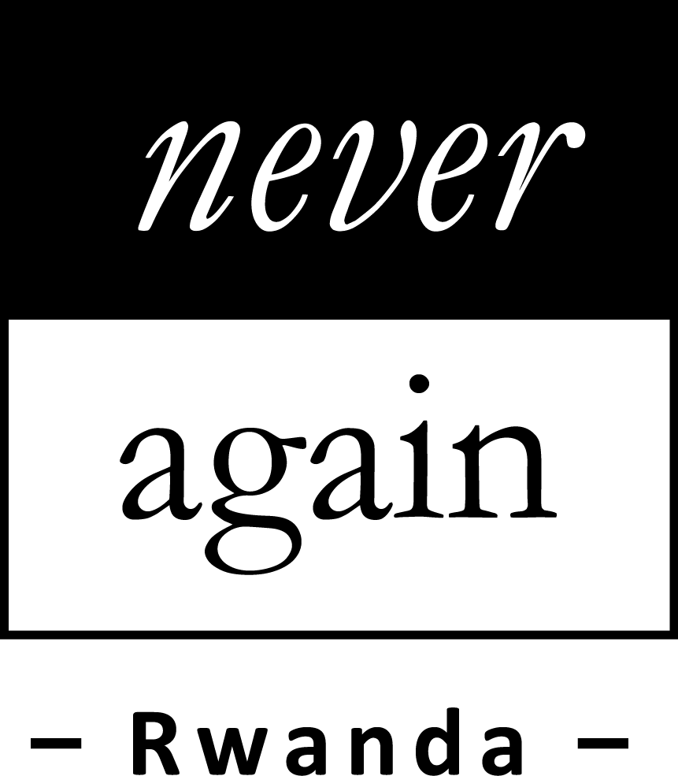14-Day Itinerary for Peacebuilding Institute
June 18th – July 1st, 2011
Rwanda

FRIDAY, JUNE 17TH
- Airport arrival of American participants
- American participants go to their accommodation (e.g., St. Francois)
DAY 1: SATURDAY, JUNE 18TH
- Airport arrival of remaining American participants
- Welcome session for American and Rwandan participants
  - NAR Team introduce themselves and welcome participants; they describe vision behind the institute, review itinerary and safety procedures, etc.
  - ACTIVITY: Name game and ice-breakers
- American participants orientation
DAY 2: SUNDAY, JUNE 19TH TOPIC: GENOCIDE: HISTORY AND PREVENTION
AM | - ACTIVITY: Ice-breaker  - DISCUSSION: Cross-cultural understanding and dialogue  - ACTIVITY: Setting group discussion guidelines
PM | - SITE VISIT: Tour of Gisozi Memorial Site  - ACTIVITY: Group check-in
DAY 3: MONDAY, JUNE 20TH TOPIC: GENOCIDE: HISTORY AND PREVENTION
AM | - ACTIVITY: Screening Rwandan film clips  - DISCUSSION: Exploring the Genocide against Tutsi in context.
PM | - SPEAKER: Dr. MUGISHA Innocent from Ministry of Education on facing the past to educate the future
DAY 4: TUESDAY, JUNE 21ST TOPIC: GENOCIDE: HISTORY AND PREVENTION
AM | - DISCUSSION: Small group discussions on different aspects of the Genocide against Tutsi (e.g., gender, media, international community)  - SPEAKER: Dr. Therese Siebert on the role of rescuers
PM | - SPEAKER: MUCYO Jean de Dieu, Executive Secretary of National Commission for the Fight Against Genocide CNLG on strategies for genocide prevention
DAY 5: WEDNESDAY, JUNE 22ND TOPIC: TRANSITIONAL JUSTICE
AM | - DISCUSSION: Mind-mapping of aftereffects of genocide, legal consequences, and justice approaches  - SPEAKER: Dr. Stephanie Wolfe on the history of transitional justice.
PM | - SPEAKER: Senior Lecturer Usta Kaytesi from National University of Rwanda Law School on transitional justice and its implementation in Rwanda  - ACTIVITY: Screening of gacaca-court and ICTR films
DAY 6: THURSDAY, JUNE 23RD TOPIC: TRANSITIONAL JUSTICE
AM | - SITE VISIT: Tour of Mpanga prison
PM | - SPEAKERS: Representatives from the National Service for Gacaca Jurisdictions and ICTR on the formation, implementation and lessons learned
DAY 7: FRIDAY, JUNE 24TH TOPIC: TRANSITIONAL JUSTICE
AM | - SPEAKER: Minister of Justice on the future of justice system in Rwanda
PM | - DISCUSSION: International vs. Rwandan perceptions of transitional justice programs
DAY 8: SATURDAY, JUNE 25TH TOPIC: UNITY AND RECONCILIATION
AM | - Umuganda
PM | - Free afternoon
DAY 9: SUNDAY, JUNE 26TH TOPIC: UNITY AND RECONCILIATION
- SITE VISIT: Tour of the King’s Palace and Art Museum at Nyanza
- DISCUSSION: Identity Construction
- Spend the night in Huye (former Butare)
DAY 10: MONDAY, JUNE 27TH TOPIC: UNITY AND RECONCILIATION
AM | - SITE VISIT: Tour of National Museum in Huye (former Butare) and watch a Rwandan traditional dance performance
PM | - SITE VISIT: Tour of National University of Rwanda by NAR Club  - DISCUSSION: Reflections on history, identity, and the future
DAY 11: TUESDAY, JUNE 28TH TOPIC: UNITY AND RECONCILIATION
AM | - Return to Kigali
PM | - SPEAKER: Representative from the National Unity and Reconciliation Commission on strategies to promote unity and reconciliation
DAY 12: WEDNESDAY, JUNE 29TH TOPIC: DEMOCRACY AND GOOD GOVERNANCE
AM | - DISCUSSION: Discussion on definitions and application of democracy and governance.  - SPEAKER: Government representative TBA
PM | - SITE VISIT: Tour of Parliament

DAY 13: THURSDAY, JUNE 30TH TOPIC: DEMOCRACY AND GOOD GOVERNANCE
AM | - SPEAKER: Prof. SHYAKA Amaste of Good Governance Advisory Council and Dr. Paul Kaiser, Democracy and Good Governance Advisor for USAID
PM | - DISCUSSION: Good governance in post-conflict societies
DAY 14: FRIDAY, JULY 1ST
AM | - Reflections on the Peacebuilding Institute  - Peacebuilding Institute evaluation  - Internship placement meeting
PM | - Farewell dinner with all participants, host family representatives, and NAR Team

