GODDARD SCHOOL OF BUSINESS & ECONOMICS
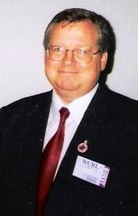
BRIAN DAVIS

