PROGRAM CHANGES
WEBER STATE UNIVERSITY

Submission Date: 10-14-13

Submitter Name: Carrie Ota

College: Education

Department: Child and Family Studies

Program Title: Early Childhood /Early Childhood Education

Check all that apply:

____New course(s) required for major, minor, emphasis, or concentration.
____Modified course(s) required for major, minor, emphasis, or concentration.
____Credit hour change(s) required for major, minor, emphasis, or concentration.
____Credit hour change(s) for a course which is required for the major, minor, emphasis, or concentration.
____Attribute change(s) for any course.
____Program name change.
____Deletion of required course(s).
____Program mode of delivery/format change (Graduate Programs ONLY)
_X___Other changes (specify) _ New course(s) for department certificate or as electives________________

JUSTIFICATION:
In the US, there is a constant push from the field of Early Childhood Education to improve the quality of care and educational experiences for young children. Requirements for caregiver qualifications, environment, and curriculum are very low nationwide. While states have tried to address these issues for years without desired outcomes, research supports technical assistance as an effective way to increase quality. In the fall of 2012, the Utah Office of Child Care took the opportunity to apply for a grant to participate in the "Creating an Effective Technical Assistance System to Develop High Quality Early Learning Programs" initiative. Utah was one of eight states that was awarded this opportunity. This grant provides the selected Utah team the opportunity to engage in a structured dialogue with national experts and other state teams to assess their current state technical assistance system on four levels (early learning programs, technical assistance professionals, supervisor/sponsoring agencies, and finally the state level). Teams are supported to create an implementation plan to establish a more effective and efficient technical assistance (TA) system that can promote high quality early care and learning programs and achieve better outcomes for children.

The Utah team goals are as follows:
1. Learn about how to set up a system that incorporates the NAEYC TA Glossary
2. Find a way to incorporate a TA Certificate of Completion info into our PD Award and Afterschool Certificate of Completion
3. Learn about and develop Core Knowledge Competencies for our TA providers
4. Develop a 9 hour college level Coaching Certificate of Completion
5. Learn how to use data collected to move the system forward

Looking at the fourth goal listed above, Utah would like to model the Certificate of Completion component after one being used in Colorado (http://www.cocoaches.net/Home_Page.html). The University of Colorado offers the three graduate level courses to complete this early childhood coaching Certificate of Completion.

WSU and the Child and Family Studies Department are a good fit for this type of offering. To reach a broader population of those that need coaching course work, these courses will be dual listed as CHF 4000 level and MED 6000 level.

Course 1 - CHF 4201/MED 6201 Coaching EC/ECE Professionals: Foundation & Organization of Coaching Application: Organization & Self Reflection

Course Description:
Educator coaching is an evidence-based strategy to increase program quality and teacher effectiveness in early childhood/early childhood education classrooms, programs, and home delivery systems. This course will train EC/ECE coaches using material from research-based sources, program experiences, and related theory. Participants will learn recommended practices in coaching related to early childhood and develop a systematic, individualized approach to effective coaching. Participants will learn practical strategies for coaching early childhood staff of diverse backgrounds and varying adult learning styles. Materials and discussions will include theory, research, interpersonal communication skills, and a systematic approach to more intentional coaching. Students will apply these strategies to Case Studies and field work experiences throughout the course and will participate in hands-on activities in class to apply new skills. Educator coaching skills will apply to any early childhood/early childhood education curriculum or model. This is course 1 in a three course series for the Utah Coaching Certificate of Completion.

Objectives:
- Identify behavioral practices of an effective coach.
- Identify and describe major principles of recommended practices for coaching in EC/ECE.
- Reflect on own coaching practices.
- Consider and practice the use of video for improving coaching skills and the delivery of the coaching process.
- Apply appropriate communication skills with a diverse range of adult/teacher learners.
- Implement coaching action plans and track coaching progress.
- Consider sustainability and advocacy in coaching systems.
- Build a community of coaches.

Course 2 - CHF 4202/MED 6202 Coaching EC/ECE Professionals: Connecting Awareness with Application & Deepening of Practice

Course Description:
Becoming an effective educator coach is a result of theoretical understanding, introspection, thoughtful planning, application of coaching skills and knowledge, and continuous self–improvement. This course will identify effective ongoing support strategies for individuals providing educator coaching. Participants will integrate skills with effective application in real life coaching experiences. Discussions will include self-reflective practices, self- directed action, planning and goal setting, and managing progress and accountability. Students will apply these strategies to case studies and real life experiences throughout the course. Students will be encouraged to engage in self-reflection and share ideas, successes, and challenges with other students in this course. This is course 2 in a three course series for the Utah Coaching Certificate of Completion.
Prerequisite: CHF 4201/MED 6201 or instructor permission.

Objectives:
- Understand the importance of the coaching partnerships.
- Develop an understanding dynamic process of the learning relationship
- Explain the role of the coach in facilitating adult learner’s cycle of inquiry.
- Practice and reflect on the parallel process of coaching.
- Increase self-reflection and experimentation as primary learning strategies.
- Build confidence in skills that assist adult learners in developing self-awareness, self-reflection, and self-directed action to benefit the children and families whom the adult learner serves.
- Explain the purpose of coaching and the qualities of an effective coach and identify relationship-based professional development strategies and model’s
- Analyze the unique characteristics and role of the coach.

Course 3 - CHF 4203/MED 6203 Coaching EC/ECE Professionals: Attuning for Personal and Organizational Change

Course Description:
The success of the coaching relationship has been based on the trusting relationship between two peers, coach, and adult learner, through a collaborative process of co-learning. The opportunity for the adult learner to self-monitor, self-analyze, and self-modify enhances the adult learner’s own resourcefulness and alters his/her own personal understanding. In addition, when the act of coaching is a collaborative process, the coach is also allowed the same opportunity to reflect on self as part of their learning. This course is designed to support the educator coach in creating a social learning climate where a synergy of shared learning and reflective dialogue about practice are examined, analyzed and refined. Participants will integrate skills from Course 1 and 2 with opportunities to engage in conducting and constructing ongoing support strategies the educator coach can apply, refine and alter based on the adult learners’ needs, readiness, and values about practice. Using evidence-based strategies and protocols, coaching for organizational change in diverse settings (home- based programming, early care settings, classrooms, and school districts, etc.), and identifying effective ongoing personal supports will also be addressed. Students will apply these strategies to case studies and real life experiences throughout the course. This is course 3 in a three course series for the Utah Coaching Certificate of Completion.
Prerequisite: CHF 4201/MED 6201 and CHF 4202/MED 6202 or instructor permission.

Objectives:
- Identify personal skills/traits that contribute to personal coaching strategies/beliefs.
- Develop personal theory of change.
- Critically analyze and select coaching strategies.
- Recognize the systems within their own organization and how their personal contribution promotes or hinders change.
- Describe the developmental process of change, resistance to change, conflict, and transformation possible in a coach – adult learner relationship.
- Explore reflective critical-thinking practices and use a variety of methods to gain an understanding of one’s own practices in coaching.
- Identify ways to transfer skills from teaching to coaching and leadership
- Explore transition to a satisfactory conclusion of a coaching relationship and bridge to new support networks.

Copy the present program from the current catalog and add the required changes (exactly as you wish them to appear in the catalog). Use strikeout (strikeout) when deleting items in the program and highlight (highlight) when adding items. If multiple changes are being proposed, please provide a summary.

Submit the original (and 20 copies) to the Faculty Senate Office, MC 1033, and an electronic copy (Word Doc) to bstockberger @weber.edu

INFORMATION PAGE

Did this program change receive unanimous approval within the Department? X Yes___ If not, what are the major concerns raised by the opponents?

Explain any effects this program change will have on program requirements or enrollments in other departments including the Bachelor of Integrated Studies Program. In the case of similar offerings or affected programs, you should include letters from the departments in question stating their support or opposition to the proposed program.

This program change will have no anticipated effect on program requirements in other departments.

Indicate the number of credit hours for course work within the program. (Do not include credit hours for General Education, Diversity, or other courses unless those courses fulfill requirements within the proposed program.)
Early Childhood (BS): 120 credit hours
Early Childhood Education (BS): 126 credit hours
Early Childhood (AAS): 63 credit hours
Child Development Minor: 18 credit hours

Indicate the number of credit hours for course work within the current program. (Do not include credit hours for General Education, Diversity, or other courses unless those courses fulfill requirements within the current program.) See Above (no change – new courses are optional electives)__

Graduate Programs only: Describe any proposed changes in the instructional mode of delivery or course format that are program-wide in nature or that affect more than one-third of the course taught in the program (e. g. changing from in-class to online instruction).
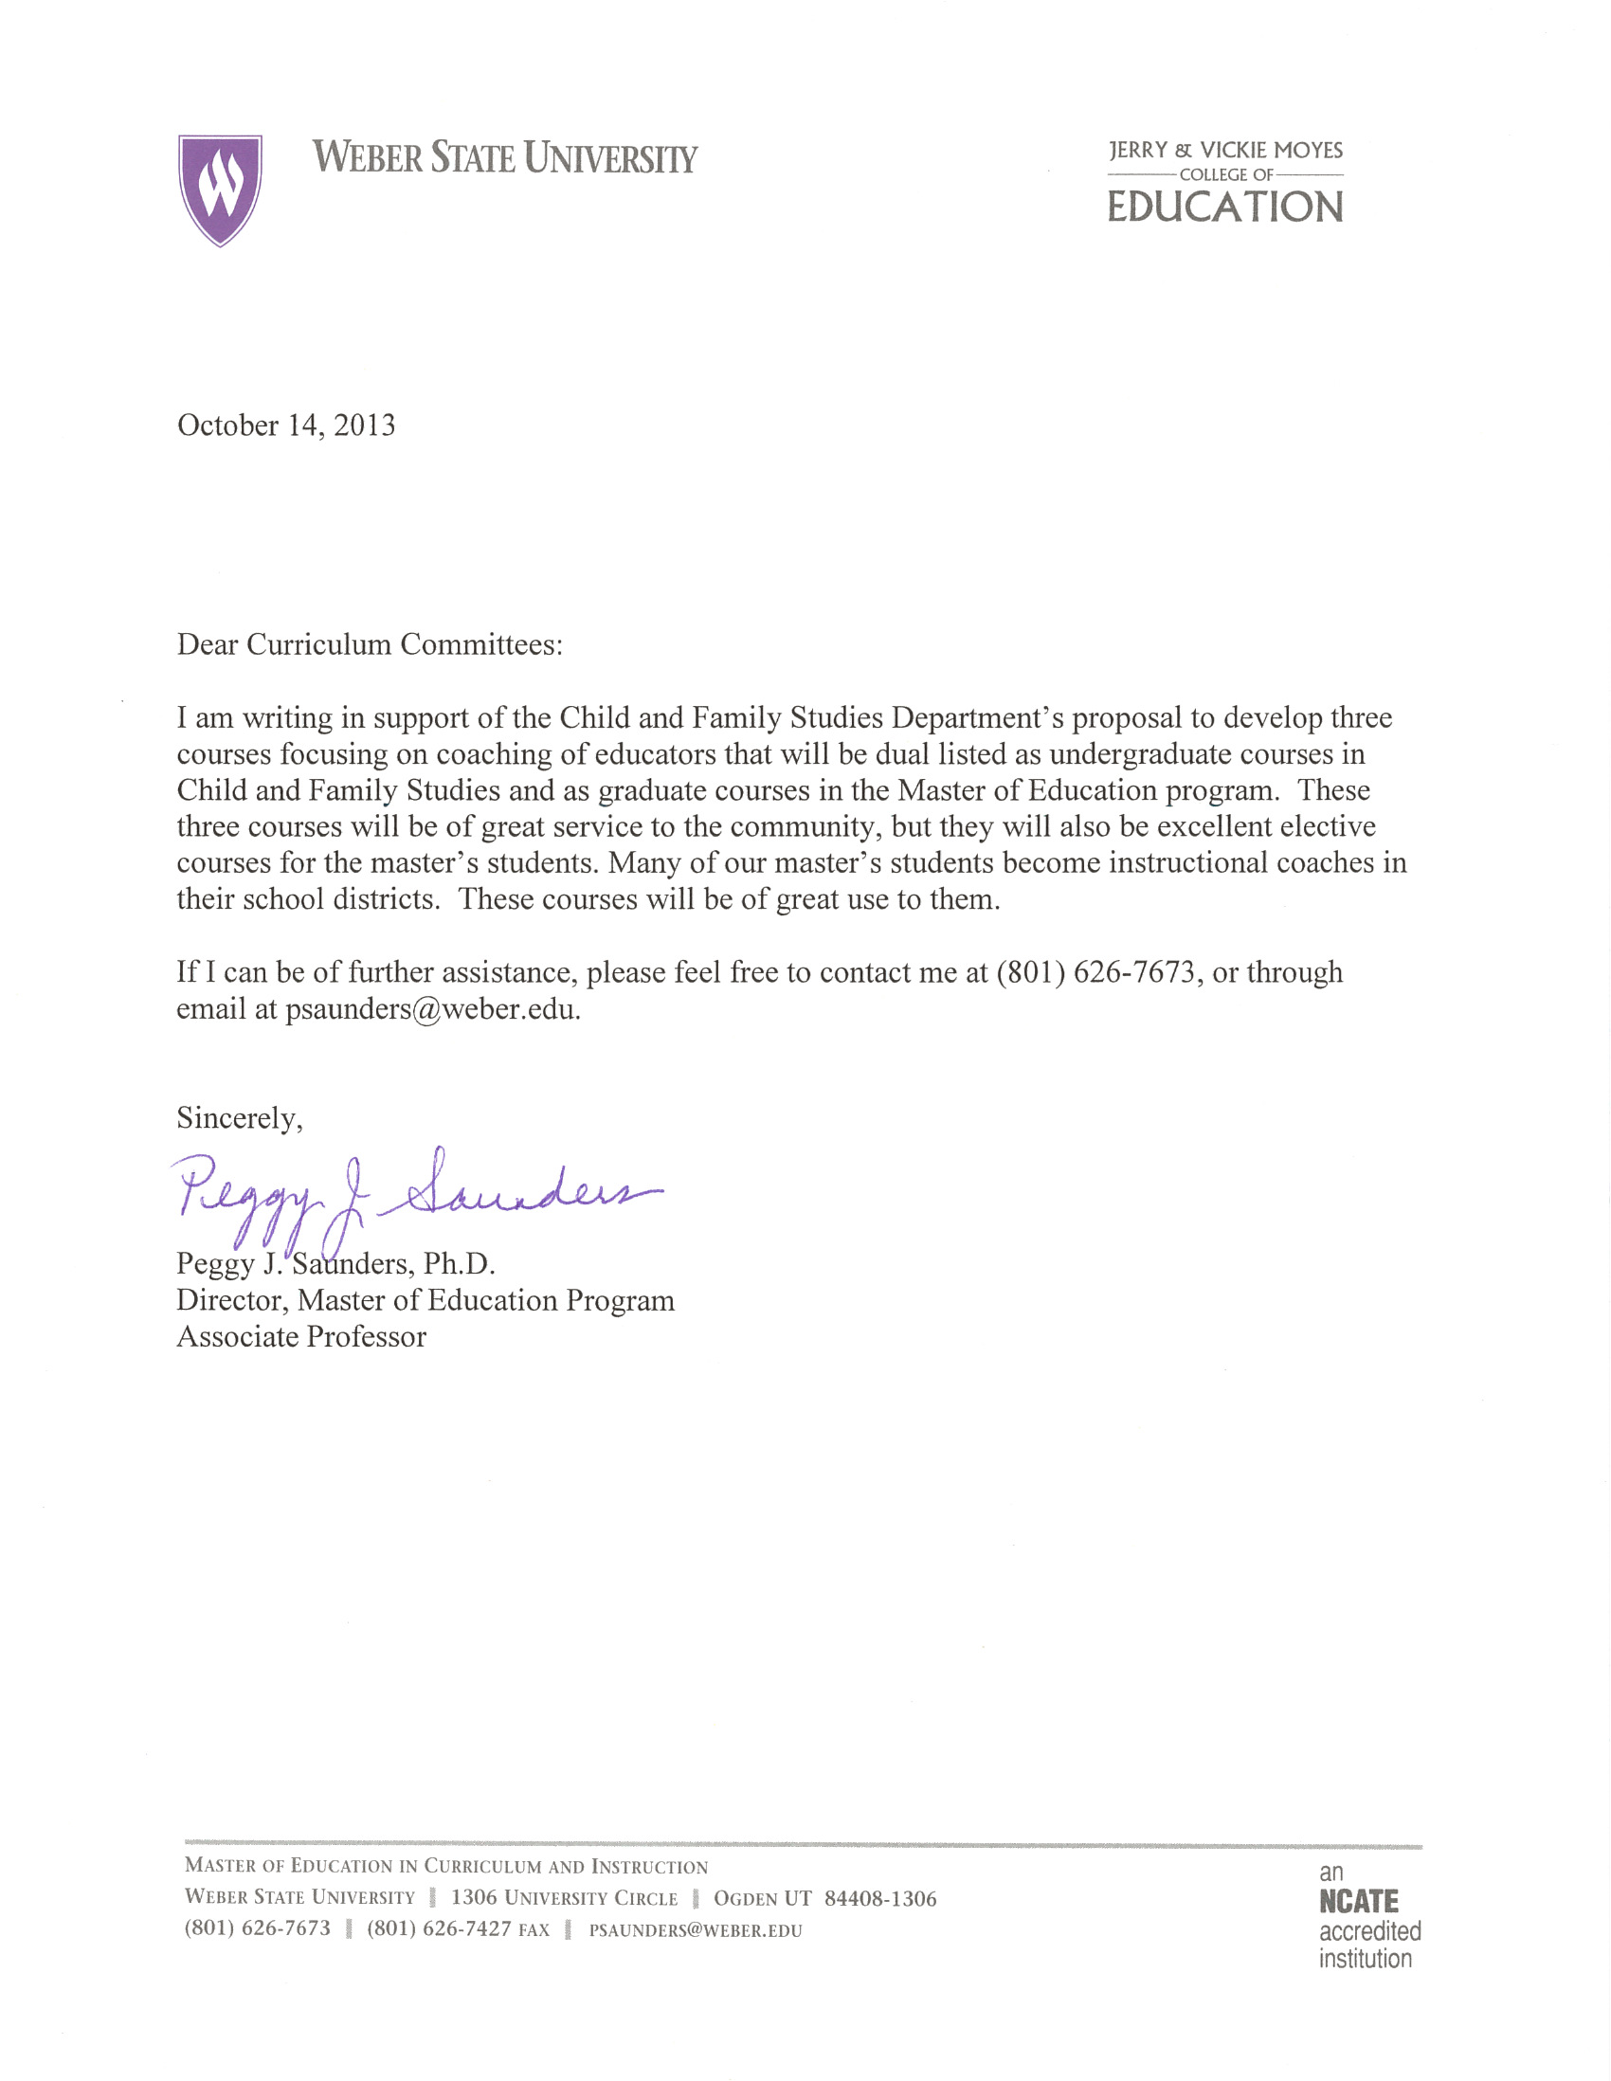

Hi, Paul,

Your program changes sound like very positive and worthwhile developments. From the perspective of the Business Administration department, I see no reason for objection. On the contrary--I wish you all the best in this endeavor!

Best regards.

------------------------------------------------
Michael J. Stevens, PhD
Professor of Management
Dept. Chair, Business Admin.
mjstevens@weber.edu
(801) 626-8099
------------------------------------------------

