PROGRAM CHANGES
WEBER STATE UNIVERSITY

Submission Date: 30 August 2013
College: Applied Science and Technology
Department: Engineering
Program Title: Electronics Engineering and Pre-Engineering
Prepared by: Kirk D. Hagen, Chair, Department of Engineering

Check all that apply:
____New course(s) required for major, minor, emphasis, or concentration.
_X__Modified course(s) required for major, minor, emphasis, or concentration.
____Credit hour change(s) required for major, minor, emphasis, or concentration.
____Credit hour change(s) for a course which is required for the major, minor, emphasis, or concentration.
____Attribute change(s) for any course.
_X__Program name change.
_X__Deletion of required course(s).
_X_Other changes (specify) __Add CS 2250 to the list of Pre-Engineering specialty courses._______________

PROPOSALS:
- Change the name of the program from “Electronics Engineering” to “Electrical Engineering.”
- Delete EE 3010 Electronic Circuits from the program.
- Change the name of EE 1000 Introduction to Electronics Engineering to EE 1000 Introduction to Electrical Engineering.
- Add CS 2250 to the list of Pre-Engineering specialty courses.
- Add prerequisite of EE 1270 to EE 3000 Engineering Seminar.
JUSTIFICATION:
1.
The Electronics Engineering program is in its third year of operation and has just been accredited by EAC of ABET (Aug. 2013). ABET defines program criteria for “Electrical, computer and similarly named engineering programs.” To be more consistent with ABET terminology and widely recognizable to students and the engineering industry, we propose to change the title of the program to “Electrical Engineering.”
The word “Electronics” in the program name is confusing to students. They routinely ask the Engineering faculty what the difference is between Electronics Engineering and Electrical Engineering. In terms of the curriculum per se, there is no difference, but because the programs at other institutions in Utah are known as Electrical Engineering, students are unsure and even suspicious of the rigor and employability of the degree.
Another troubling point is that the WSU Electronics Engineering (EE) degree is sometimes confused with the WSU Electronics Engineering Technology (EET) degree because they both contain the word “Electronics.” Some people have even expressed the view that the EE degree is essentially the same as the EET degree but with a slightly different title. The WSU EE and EET degrees are, in fact, distinctly different.
Finally, during the on-site accreditation visit fall 2012, our industrial advisory board informed the ABET team that the word “Electronics” is problematic for some local engineering companies because this term is not used in their official engineering position descriptions. Changing the program name to “Electrical Engineering” would completely remove this difficulty. The official ABET statement to this effect is given in the Appendix.
2.
The purpose of EE 3010 was to determine the preparation of students with a BS EET degree for undertaking upper division courses in the Electronics Engineering (EE) program. This course was an exam that covered mathematics and fundamental engineering principles. During spring semester 2012, the program faculty decided to consider each EET graduate on a case-by-case basis rather than applying a generic exam to all EET graduates. This change gives the Electronics Engineering coordinator the flexibility to advise EET graduates to take additional EE courses if necessary to adequately prepare the graduates for more in-depth mathematical and theoretical content.
3.
To be consistent with the name change of the program, the title of EE 1000 is being changed to Introduction to Electrical Circuits.
4.
CS 2250 Structured Computing in a Selected Language (4) is a required course in the EE program and is often taken by Pre-Engineering students who intend to major in EE at other schools. CS 2250 needs to be added to the other CS courses in the Engineering Specialty category for the Associate of Pre-Engineering (APE) degree.
5.
EE 3000 Seminar is a junior-level course. Currently, there is no prerequisite for this course, so some students register for the course as freshman or sophomores. Having a prerequisite of EE 1270 Introduction to Electrical Circuits, a sophomore level course, the EE students will not be allowed to take EE 3000 until they are juniors in the program.

Copy the present program from the current catalog and add the required changes (exactly as you wish them to appear in the catalog). Use strikeout (strikeout) when deleting items in the program and highlight (highlight) when adding items. If multiple changes are being proposed, please provide a summary.
Submit the original to the Faculty Senate Office, MC 1033, and an electronic copy to:
bstockberger @weber.edu

WSU Catalog:
Department Chair: Kirk D. Hagen
Location: Building 4, Room 421
Telephone Contact: Susan Foss 801-626-6898
Email: susanfoss@weber.edu
Professor: Kirk Hagen; Associate Professors: Justin Jackson, Jeffrey Ward; Assistant Professors: Fon Brown, Larry Zeng; Visiting Professor: Christopher Trampel

Engineering is the application of science and mathematics to the optimum conversion of the resources of nature to the uses of humankind. More specifically, engineering is the creative application of scientific principles to design and develop devices, systems and processes to satisfy the needs of society.

Engineering is a broad field, consisting of a variety of disciplines such as biomedical, chemical, civil, electrical and mechanical engineering. For example, biomedical engineers design artificial organs and diagnostic systems to detect and treat diseases. Chemical engineers design fuels, plastics and drugs. Civil engineers design roads, buildings, bridges and water treatment plants. Electrical and electronics engineers design computers, communication devices and power control systems. Mechanical engineers design machines, spacecraft, power plants and heating and air-conditioning systems.

The Department of Engineering houses two academic programs, Electronics Electrical Engineering and Pre-Engineering. The Electronics Electrical Engineering Program prepares the student to enter the engineering industry or graduate school in the discipline. The Pre-Engineering Program constitutes the first two years of a bachelor’s program and prepares the student to transfer to another institution to complete the four-year engineering degree.

The Engineering Department offers a Bachelor of Science (BS) degree in Electronics Electrical Engineering and an Associate of Pre-Engineering (APE) degree.

Programs
Associate of Pre-Engineering
•Pre-Engineering (APE)
Bachelor of Science
•Electronics Electrical Engineering (BS)
Return to: College of Applied Science & Technology

Electronics Electrical Engineering (BS)
--------------------------------------------------------------------------------
•Program Prerequisite: Not required.
•Minor: Not required.
•Grade Requirements: A grade of “C” or better in all EE and support courses is required for this major (a grade of “C-” is not acceptable). Students must have an overall GPA of 2.5 or higher to graduate.
•Credit Hour Requirements: A total of 125 credit hours is required for graduation.
Electronics Electrical Engineering is the branch of engineering that deals with the design and development of electronic electrical devices and systems such as computers, telecommunications and controls. The Electronics Electrical Engineering Program offers courses in basic analog and digital circuits, microelectronic systems, electromagnetics, embedded systems, and signal processing. An internship, which gives students engineering work experience, is also part of the program. In the senior year, students complete a two-semester capstone project that integrates their course work. The program prepares graduates to enter engineering industry or pursue advanced studies in the discipline.

Program Educational Objectives
Educational objectives are the career and life accomplishments that the program prepares graduates
to achieve within a few years after graduation. The educational objectives of the WSU Electronics
Electrical Engineering Program are to produce graduates that are able to:

•Design and develop electronic electrical systems.
•Effectively communicate technical information and participate in a team environment.
•Engage in life-long learning through continuing education and industrial practice.
•Demonstrate professional ethics and social awareness.

Accreditation
The Weber State University Electrical Engineering program is accredited by the Engineering Accreditation Commission (EAC) of ABET.
Electronics Engineering is a new program at WSU and hence is not yet accredited by ABET. As the program now has its first graduates from the 2011-2012 academic year, WSU has applied for accreditation to the Engineering Accreditation Commission (EAC) of ABET. WSU will be notified by ABET July 2013.

Advisement
All Electronics Electrical Engineering students are required to meet with their faculty advisor at least annually for course and program advisement. Please call the department secretary at 801-626-6898 for the name of your advisor and to schedule an appointment. Individual student records are accessible through the WSU Home Page.

Admission Requirements
See the faculty advisor or department secretary to declare your program of study (major).

General Education
Refer to Degree and General Education Requirements for Bachelor of Science degrees. Consult with your advisor and refer to the major requirements below for specific general education courses required.

Major Course Requirements for EE BS Degree

--------------------------------------------------------------------------------
Electronics Electrical Engineering Required Courses (49 credit hours)
--------------------------------------------------------------------------------
•EE 1000 - Introduction to Electronics Electrical Engineering (2) or
•ENGR 1000 - Introduction to Engineering (2)
•EE 1270 - Introduction to Electrical Circuits (4)
•EE 2260 - Fundamentals of Electrical Circuits (4)
•EE 2700 - Digital Circuits (4)
•EE 3000 - Engineering Seminar (1)
•EE 3110 - Microelectronics I (4)
•EE 3120 - Microelectronics II (4)
•EE 3210 - Signals and Systems (4)
•EE 3310 - Electromagnetics I (4)
•EE 3610 - Digital Systems (4)
•EE 3710 - Embedded Systems (4)
•EE 3890 - Internship (2)
•EE 4010 - Senior Project I (2)
•EE 4020 - Senior Project II (2)
•EE 4100 - Control Systems (4)

Electronics Electrical Engineering Elective Courses (6 credit hours)
--------------------------------------------------------------------------------
Select 6 credit hours from the following 4000 level courses.

•EE 4210 - Digital Signal Processing (3)
•EE 4310 - Electromagnetics II (3)
•EE 4410 - Communication Circuits and Systems (3)
•EE 4800 - Individual Studies (1-4)
•EE 4900 - Special Topics (1-4)
Support Courses Required (minimum of 27 credit hours)
--------------------------------------------------------------------------------
•CS 2250 - Structured Computing in a Selected Language (4)
or both
•CS 1400 - Fundamentals of Programming (4) and
•CS 1410 - Object-Oriented Programming (4)
•ENGL 3100 - Professional and Technical Writing (3) or
•NTM 3250 - Business Communication (3)
•MATH 1220 - Calculus II (4)
•MATH 2210 - Calculus III (4)
•MATH 2250 - Linear Algebra and Differential Equations (4)
or both
•MATH 2270 - Elementary Linear Algebra (3) and
•MATH 2280 - Ordinary Differential Equations (3)
•MATH 3410 - Probability and Statistics I (3)
•PHYS 2220 - Physics for Scientists and Engineers II (5)
General Education Courses Required (40-43 credit hours)
--------------------------------------------------------------------------------
•ENGL 2010 EN - Intermediate College Writing (3)
prerequisite is ENGL 1010 Introductory College Writing (3) or equivalent

•American Institutions (AI) (3)
•MATH 1210 - Calculus I (4)
•Computer & Information Literacy (2)
•COMM 2110 HU - Interpersonal & Small Group Communication (3)
•Humanities and Creative Arts (HU/CA) (6)
•ECON 2010 SS - Principles of Microeconomics (3)
•Social Science and Diversity (SS/DV) (3)
•CHEM 1210 PS - Principles of Chemistry I (5)
•PHYS 2210 PS - Physics for Scientists and Engineers I (5)
•Life Science (LS) (3)
Course Requirements for EE Major Second BS Degree

--------------------------------------------------------------------------------

Students that have completed a BS EET from a TAC ABET accredited program are required to take the following courses to obtain a BS in Electronics Electrical Engineering.

•MATH 3410 - Probability and Statistics I (3)
•EE 3010 - Electronic Circuits (2)
•EE 3110 - Microelectronics I (4)
•EE 3120 - Microelectronics II (4)
•EE 3210 - Signals and Systems (4)
•EE 3310 - Electromagnetics I (4)
•EE 3610 - Digital Systems (4)
Note:
--------------------------------------------------------------------------------

This assumes all prerequisite and University residency hours have been met. Refer to Second Bachelor’s Degree under Graduation in the Academic Information section of this catalog.

EE 3000 - Engineering Seminar
Credits: (1)
Typically taught:
Fall [Full Sem]
An engineering seminar course designed to prepare the student for professional engineering employment. Topics to include resumes, hiring criteria, interviewing techniques, engineering ethics, professional and societal responsibilities, lifelong learning, diversity, creative problem solving, goals, quality, timeliness, and continuous improvement. The students will research related topics and write a paper. Prerequisite: EE 1270

Associate of Pre-Engineering section of the catalog:

Engineering Specialty Courses (22 credit hours minimum)

Engineering specialty courses are those that are required for specific engineering disciplines at the receiving universities. With the assistance of the Pre-Engineering coordinator, students should take courses that apply to their particular engineering major at the university to which they plan to transfer. The specialty courses listed below apply generally, but do not constitute a list of specific course requirements for any particular receiving university. Engineering specialty course requirements for the University of Utah and Utah State University may be obtained from the Pre-Engineering coordinator or the applicable engineering department at these institutions.
- CHEM 1210 PS - Principles of Chemistry I Credits: (5)
- CHEM 1220 - Principles of Chemistry II Credits: (5)
- CHEM 2310 - Organic Chemistry I Credits: (4)
- CHEM 2320 - Organic Chemistry II Credits: (4)
- CHEM 3070 - Biochemistry I Credits: (4)

- CS 1023 - Selected Programming Language Credits: (4)
- CS 1030 - Foundations of Computer Science Credits: (4)
- CS 1400 - Fundamentals of Programming Credits: (4)
- CS 1410 - Object-Oriented Programming Credits: (4)
- CS 2250 – Structured Computing in a Selected Language Credits: (4)

- DET 1060 - Fundamentals of Mechanical Drafting Using 3D CAD Credits: (3)

- ENGR 2010 - Statics Credits: (3)
- ENGR 2080 - Dynamics Credits: (4)
- ENGR 2140 - Strength of Materials Credits: (3)
- ENGR 2160 - Materials Science and Engineering Credits: (3)
- ENGR 2210 - Electrical Engineering for Non-majors Credits: (4)
- ENGR 2300 - Thermodynamics I Credits: (3)

- EE 1270 - Introduction to Electrical Circuits Credits: (4)
- EE 2260 - Fundamentals of Electrical Circuits Credits: (4)
- EE 2700 - Digital Circuits Credits: (4)

- GEO 1110 PS - Dynamic Earth: Physical Geology Credits: (3) and
- GEO 1115 - Physical Geology Lab Credits: (1)

- MATH 2210 - Calculus III Credits: (4)
- MATH 2250 - Linear Algebra and Differential Equations Credits: (4)
- MATH 2270 - Elementary Linear Algebra Credits: (3)
- MATH 2280 - Ordinary Differential Equations Credits: (3)
- MATH 3410 - Probability and Statistics I Credits: (3)

- MICR 2054 LS - Principles of Microbiology Credits: (4)

INFORMATION PAGE

Did this program change receive unanimous approval within the Department? _Yes_ If not, what are the major concerns raised by the opponents?

Explain any effects this program change will have on program requirements or enrollments in other departments including the Bachelor of Integrated Studies Program. In the case of similar offerings or affected programs, you should include letters from the departments in question stating their support or opposition to the proposed program.

The progam change will not effect program requirements or enrollments in other departments, including the BIS Program. Letters from the Departments of Computer Science, Mathematics, Physics and Chemistry are included in the Appendix.

Indicate the number of credit hours for course work within the program. (Do not include credit hours for General Education, Diversity, or other courses unless those courses fulfill requirements within the proposed program.) 125

No change in credit hours is being proposed.

Indicate the number of credit hours for course work within the current program. (Do not include credit hours for General Education, Diversity, or other courses unless those courses fulfill requirements within the current program.) 125

No change in credit hours is being proposed. The two credit hours for EE 3010 are not counted in the total credit hours because this course was an “assessment” course used solely to determine the preparation of EET graduates for the EE program.

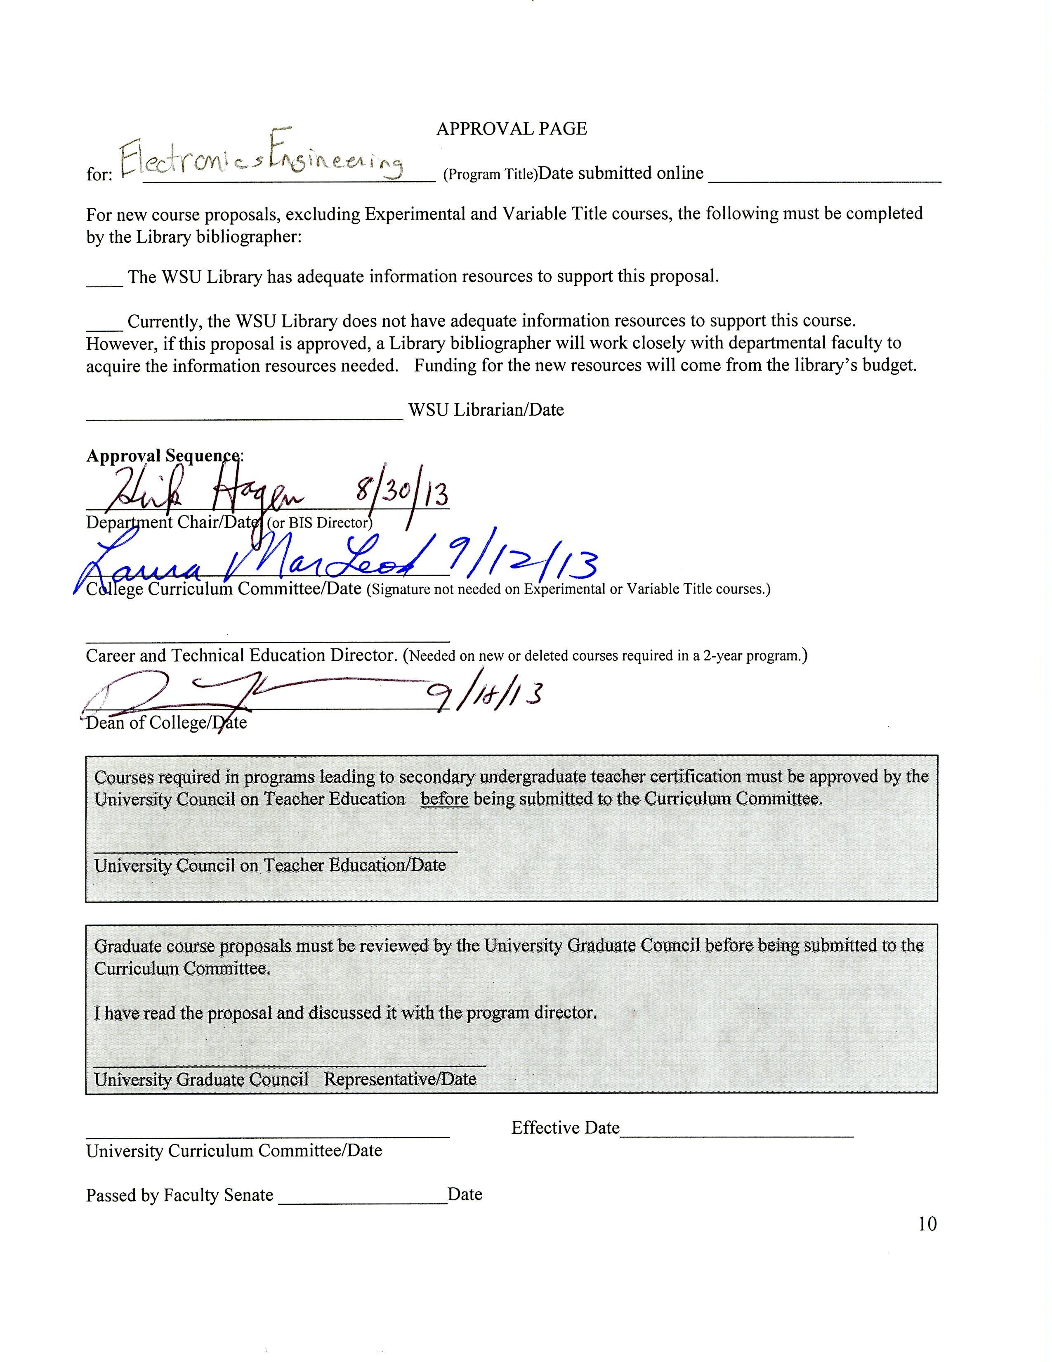

Appendix

(Excerpt from ABET report on name change recommendation)

(Support letters from Computer Science, Mathematics, Physics and Chemistry)

