The Way We Read Now

A new survey of America’s favorite novels shows that storytelling moves us far more than literary quality.

By Adam Kirsch, Wall Street Journal (For classroom use only)
Aug. 3, 2018 10:40 a.m. ET
When the novelist Philip Roth died in May, the obituaries and tributes agreed that he was (to quote a few choice descriptions) “towering,” “pre-eminent” and a “giant of the American novel.” In the opinion of those who create the official narrative of American literature—the critics who write about it, the professors who teach it, the publishers who sell it—there was no one bigger than Roth. The one question few stopped to ask—and maybe an obituary was not the place to ask it—is whether the reading public agreed. Is Philip Roth in fact one of America’s favorite novelists? Can such a thing even be measured?
As it turns out, it can—and he isn’t. We know this thanks to “The Great American Read,” a new initiative from PBS, which set out to produce a list of America’s 100 favorite works of fiction. The alphabetical list (the books aren’t ranked) was released this spring, based on a poll of more than 7,000 American readers. The results of the poll were winnowed down by an advisory panel of “literary industry professionals” using a few rules: The books had to be published (though not necessarily written) in English, with a series like “Harry Potter” counted as one title, and there could be no more than one book per author.
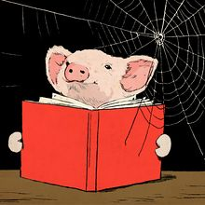
ILLUSTRATION: RUTH GWILY
This month, a companion volume called “The Book of Books” will be published, with pithy one-page essays discussing the background and significance of each of the chosen hundred. Starting in September, PBS will broadcast a Great American Read series, hosted by Meredith Vieira and featuring interviews with celebrities, literary and otherwise. All of this will culminate in October with the announcement of America’s favorite novel, as determined by online voting.
Whatever book turns out to win that honor, it won’t be “ Portnoy’s Complaint” or “American Pastoral”—Roth novels that would feature on many experts’ lists of the greatest American fiction. That’s because not a single book by Roth made it onto the Great American Read’s top 100. But then, he is in good company. Among the American novelists missing from the list are Nobel Prize winners like Sinclair Lewis, William Faulkner, and Saul Bellow; legendary names like Flannery O’Connor and Edith Wharton ; and living greats such as Joyce Carol Oates and Jonathan Franzen, whose 2001 novel “The Corrections” sold around three million copies.
If Americans don’t love the books that are usually supposed to constitute American literature, then what do we love? One answer the Great American Read list provides is that we love the books we read as children or teenagers. A few venerable children’s classics retain a stubborn foothold in the memory of readers: “ Tom Sawyer, ” “The Call of the Wild.” But these are not the books most of us actually grow up reading today. We are more likely to cut our teeth on children’s fantasy titles, which make a strong showing on the list, especially when they come from Britain: “Harry Potter,” of course, but also the Narnia books, “The Lord of the Rings” and the founder of the genre, “Alice’s Adventures in Wonderland.”
Alongside these early favorites are the accessible literary works that feature on many a middle school syllabus, often as the first “grown-up” books we read: Harper Lee’s courtroom drama “To Kill a Mockingbird,” John Knowles’s boarding-school story “A Separate Peace,” John Steinbeck’s Depression-era saga “The Grapes of Wrath.” Perhaps there is a similar touch of nostalgia involved in the choice of more challenging classics like “Moby-Dick” and “Heart of Darkness,” which are often read in high school or college and then not opened again.
But other categories stand out that have nothing to do with school. The Great American Read list is heavy on genre writing: science fiction (“Jurassic Park,” “Ready Player One”), mysteries and thrillers (“The Da Vinci Code,” “Gone Girl”), and other best sellers (“Lonesome Dove,” “The Help,” “The Clan of the Cave Bear”). Such books get little respect from critics and are seldom taught in classrooms, but they are the ones that people remember and love. Certainly, they far outweigh contemporary literary fiction on the top 100 list, though a few such titles do make an appearance— Toni Morrison’s “Beloved,” Junot Díaz’s “The Brief Wondrous Life of Oscar Wao.”
In every genre, the Great American Read list is very much a snapshot of a moment in time. Thirty years ago, or 30 years from now, a similar poll would find other titles to take pride of place. You can see this happening in the absence from the list of books that were once enormously popular, like the Sherlock Holmes stories of Arthur Conan Doyle and the pioneering science fiction of H.G. Wells. ( Mary Shelley’s “Frankenstein,” however, does make the cut.) By my count, of the 100 titles on the list, 23 were published in the 21st century—that is, in less than the last 20 years—and another 60 were published in the 20th century. That leaves just 17 titles to represent the previous 3,000 years of world literature.
By the same token, literature in translation makes a poor showing among America’s favorites. Sixty-seven of the top 100 titles were written in the U.S. and another 19 in Britain, leaving just 14 to represent the rest of the world (and that includes English-language writing from Canada, Nigeria and elsewhere). “War and Peace” and “Crime and Punishment” take care of Russian literature; “The Count of Monte Cristo” and “The Little Prince ” represent France. The foreign language with the highest representation on the list is Spanish, with books by Gabriel García Márquez and Rómulo Gallegos joining Cervantes ’ masterpiece, “Don Quixote,” which is the oldest book chosen (it was originally published in 1605).
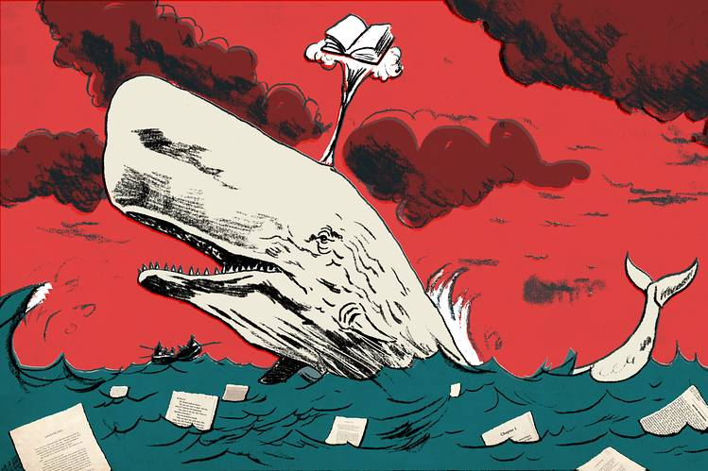
ILLUSTRATION: RUTH GWILY
Beyond statistics, however, there are also literary insights that can be deduced from the Great American Read list. For one thing, it seems clear that American readers don’t care very much about good prose. “The Da Vinci Code” and “Fifty Shades of Grey” are regularly cited as examples of terrible writing, but both were mega-best sellers, and both find a place among the top 100. This is not simply a matter of readers preferring genre writing to literary writing. Rather, it appears that, in any genre, readers prefer strictly functional prose to stylistic elegance or idiosyncrasy. Isaac Asimov is on the top 100 list, but not Philip K. Dick ; James Patterson’s Alex Cross mysteries and Agatha Christie’s “And Then There Were None,” but not Elmore Leonard or Raymond Chandler.
Another way of putting it is that when Americans read, we mostly read for story, not for style. We want to know what happens next, and not to be slowed down by writing that calls attention to itself. According to one familiar indictment of modern literature, today’s literary writers are unpopular precisely because they have lost interest in telling stories and become obsessed with technique. In the 20th century, this argument goes, literature became esoteric, self-regarding and difficult, losing both the storytelling power and the mass readership that writers like Balzac, Dickens and Twain had enjoyed.
One classic expression of this complaint was made by the journalist-turned-novelist Tom Wolfe, in his 1989 essay “Stalking the Billion-Footed Beast.” After about 1960, Wolfe argued, the novel was no longer about “tak[ing] real life and spread[ing] it across the pages of a book”; instead, it had degenerated into “a sublime literary game.” One of his particular targets of criticism was none other than Philip Roth, whom Wolfe attacked for turning away from the realistic style of his early work. Wolfe’s own novels, like “The Bonfire of the Vanities,” were a deliberate attempt to reverse this trend, to restore accessible realism to its place at the center of fiction.
‘Perhaps, for many readers, it does not make much difference whether a story is told in print on a page or images on a screen.’
Yet the truth revealed by the Great American Read list is that realism does not seem any more beloved by American readers than postmodernism. Neither Wolfe’s novels nor other classics of American realism—the “Rabbit” books of John Updike, the terse stories of Raymond Carver —make the top 100. On the contrary, most of our favorite books offer stories that are larger than life. It is no coincidence that many of the recent books on the list were made into popular films or TV shows. In addition to “The Da Vinci Code” and “Fifty Shades of Grey,” we find “Jurassic Park,” “The Hunt for Red October,” and “A Song of Ice and Fire,” the series that became “Game of Thrones.” These are all high-concept stories, in which exciting adventures take place in fantastic or specialized worlds. They were movies in prose even before they were translated to the screen.
Perhaps, for many readers, it does not make much difference whether a story is told in print on a page or images on a screen. The narrative itself is what matters. In fact, the Great American Read list confirms that there is a great hunger in our culture for grand, mythic narratives. The adoration of the Harry Potter books, like the nearly scriptural status of the Star Wars movies, involves more than just fandom. These are comprehensive universes, complete with their own laws and histories, heroes and villains, morals and meanings. They serve the purpose that was once served by epic poems like “The Iliad” or “The Odyssey,” or even by biblical stories: They dramatize the spiritual truths and longings that shape our world.
Indeed, while there are some books on the top 100 list that could be categorized as strictly escapist entertainment, what’s striking is how many of them have a serious, didactic purpose. Americans are a moralistic people—that’s one reason why we argue so bitterly about politics—and our books reflect our love of sermons. “Atlas Shrugged” is a sermon on individualism and capitalism, just as “The Handmaid’s Tale” is a sermon on feminism and patriarchy. “The Catcher in the Rye” and “ Siddhartha ” are books that help young people, in particular, formulate a whole philosophy of life.
Then there are tales of good fighting against evil, whether they take the form of teen fantasies like “The Hunger Games” and “Twilight” or use an explicitly Christian vocabulary, such as Frank E. Peretti’s “This Present Darkness” and the “Left Behind” series, which is set in a post-Rapture world. In a sense, you could say that the most influential book on the list is John Bunyan’s “The Pilgrim’s Progress,” from 1678, which helped to pioneer the combination of religious moralizing and fantastic adventure.
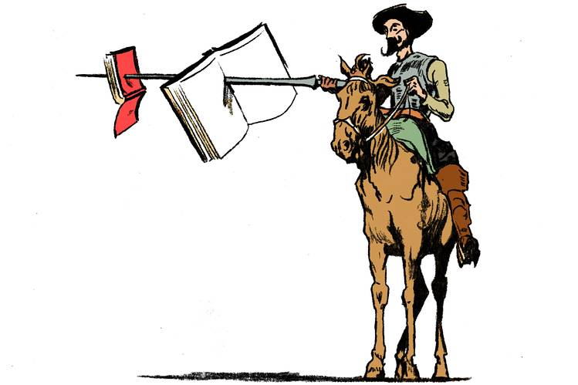
ILLUSTRATION: RUTH GWILY
The need for such epic stories predates printed or even written literature and will survive even if books disappear, as many writers and readers now fear. In fact, the most interesting thing about the Great American Read list is the way it reminds us that stories are something separate from, and more fundamental than, what we call fiction, which is a fairly recent category, historically speaking. After all, it wasn’t until the 18th century that the novel became a dominant literary form, first in Europe and then around the world.
In his classic 1936 essay “The Storyteller,” the German literary critic Walter Benjamin argued that the novel was in some ways actually the opposite of traditional storytelling. “What distinguishes the novel from the story,” he wrote, “is its essential dependence on the book.”
Books can be well or badly written, and it is a taste for the art of writing that makes people interested in literature, where the “how” of the tale matters as much as, or more than, the “what” and “why.” That is why literary taste, like taste in food or music, can be educated: We learn to enjoy things more, and to enjoy more things, as we accumulate experience in reading. But before taste comes the need for sustenance, and that is what America’s favorite books provide: the stories that we need to make sense of our lives.

MORE ESSAYS

