Using Mental Imagery to Improve the Return from Sport Injury
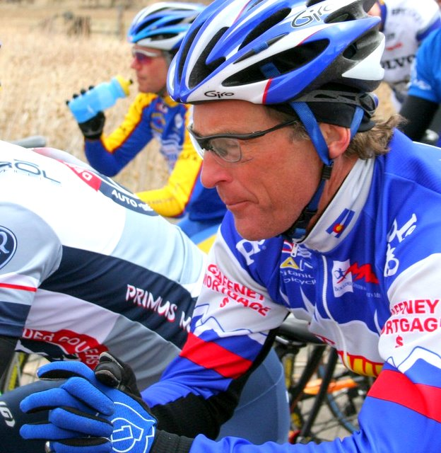
By J. Jordan Hamson, Ph.D., ATC
Have you ever wondered how the power of the mind could be used to help you recover from sport-injury?
Elite, collegiate, and even youth athletes use mental techniques, like imagery, to improve performance and to learn new sport skills. Due to the demonstrated effectiveness of mental imagery, athletes should be encouraged to transfer imagery use to situations outside of sport performance, such as return to sport following injury.
How can imagery be used to augment recovery from sport injury? When athletes become injured, mental imagery can be used to rehearse skills, to set rehabilitation goals, to promote healing within the body, and to relax when faced with the pain of rehabilitation. Time away from sport can be offset by substituting “mental practice” by visualizing sport skills, rehearsing strategic plays or game plans, and reviewing past successful performances. In injury rehabilitation, imagery aids the athlete to organize goals and provides the motivation to achieve those goals. Each athlete”s focus is productively channeled toward what they can do, as opposed to what they can’t.
Healing Imagery
When injured, the athlete may also benefit from using imagery to guide the healing process as it occurs within the body. This is commonly termed “healing imagery” and has been shown to speed up the recovery process in injured athletes (Ievleva & Orlick, 1991). Healing imagery guides the injured athlete to “see” healing occurring in the injured joint (e.g., seeing the blood stream bring damaged tissues away from the injury reducing swelling, and seeing the new cells repairing the damaged area) and to “feel” tissues getting stronger (e.g., visualizing ligaments feeling as strong as steel, or as many fibers linking together). Healing imagery may also be effective due to the relaxation component that often accompanies the use of imagery techniques.
Relaxation Imagery
With injury, blood flow is increased to the joint or injured area causing swelling, pain, and immobility. Pain following injury is also produced by muscle spasms, which is evidence of the body’s attempt to protect the injured area from further damage. Relaxation can alter the injured joint/area by causing physical changes at the injury site. Relaxation imagery (e.g., imaging a pleasant scene such as a waterfall, a soothing stream, or a sunset) promotes physical relaxation of the musculature surrounding the injured joint, allowing for blood flow to return to normal and encouraging healing and rebuilding in the area. Relaxation can be helpful in the face of physiological stress and has been shown to aid in reducing pain associated with injury and injury rehabilitation (Dridiger, Hall, & Callow, 2006; Evans, Hare, & Mullen, 2006).
Phases of Injury Rehabilitation
If you are an injured athlete, and have used mental imagery for sport performance enhancement, you are ready to get started. If you have not used mental imagery prior to your injury, you can begin to refine your imagery skills with the strategies listed above and apply them to your injury rehabilitation when your images are controllable and vivid. To implement mental imagery into the recovery from sport-injury, first consider the phase of injury rehabilitation. There are three main phases and corresponding physiological components:
1. Initial injury, which is accompanied by swelling, muscle tension, pain, and lack mobility;
2. Strengthening, which is accompanied by return of mobility and reduction of swelling and pain; and
3. Return to sport, which is accompanied by near normal function and strength of the injured joint (Hamson 2006).
Mental Imagery for Each Phase of Rehabilitation
Each of these phases requires a different focus and function for mental imagery. In the initial injury phase, relaxation imagery is most useful to control the pain associated with the physiological and psychological injury response. In this phase, you are recovering from the physical injury response of swelling, muscle spasm, and pain and is commonly working on increasing range of motion of the injured area, causing additional pain once initial muscle spasms have subsided. Healing is the main focus of this phase and calls for the use of healing imagery; you should be directed to form positive images of the joint repairing and tissues healing together. Education about the injury that has occurred is especially important when healing imagery is utilized to facilitate the formation of accurate images of the healing taking place. Commonly, individualized verbal scripts (with background relaxation music) are created to guide your mental imagery to the specific joint and/or type of injury that has occurred. Relaxation music alone, such as nature sounds, ocean waves, or individually selected relaxing music, can also aid during this time frame and can be found at local retail outlets.
The second phase of rehabilitation, the strengthening phase, requires a different type of imagery. Athletes have moved through gaining full range of motion and are now focused on building strength, flexibility, and balance in the injured area. Goal setting becomes a main focus; the athlete will be striving to meet set rehabilitation goals relating to strength and dynamic movement of the injured joint. The key role of mental imagery is to direct the visualization of such goals and to act as a motivator. Healing imagery is also useful during this phase. Individualized scripts are often most effective and can be created for you by a qualified athletic trainer or sport psychologist (Hamson, 2006). Guided verbal scripts, as well as scripts that include pictures of the athlete completing rehabilitation exercises (all contained on an Apple iPod) can serve both the cognitive and motivational functions of imagery. Although pain is usually present in this phase, using music that facilitates the relaxation response can lessen it.
The final phase of injury rehabilitation, the return to sport phase, is characterized by making final improvements in strength and agility (measured by the performance of sport specific skills). Issues with pain and recurrent swelling are minimal during this final phase, where the main focus turns to reducing fear of re-injury and instilling confidence in the rehabilitated joint. Negative images, those that include replaying of the injury and negative past performances, can hinder your return to sport. The mental imagery used at this stage includes verbal guidance and visual images of successful past performances (positive cues) and improves confidence in the recovering joint that it can perform at 100% without limitation. An individualized script would be most beneficial during this phase, however, general retail audiocassettes are available that guide the athlete through the rehabilitation process and return to sport (Inner Sports: Mental Skills for Peak Performance, Lydia Ievleva, 1997).
Incorporating Mental Skills in Training & Recovery
Mental imagery is not the only psychological skill of use for the injured athlete. Using positive self-talk, effective goal setting (setting both short- and long-term goals), progressive relaxation, and systematic desensitization can also aid in the recovery process. As described above, different types of mental imagery are suitable for the phases of rehabilitation that each athlete goes through. The time spent in each of the three phases is highly variable due to injury type and severity, however, each individual injury can benefit from the use of mental imagery in some capacity. Furthermore, the goal of sports medicine professionals who work with injured athletes (e.g., athletic trainers and physical therapists) is to return the injured athlete back to the playing field as soon as they are mentally and physically ready. Mental imagery, as well as other psychological techniques, should be considered suitable treatments alongside traditional physical rehabilitation programs. Athletes are encouraged to ask their sports medicine professionals questions about potentially useful psychological skills and individuals who can aid the athlete in the implementation of these skills within the injury rehabilitation program.
Dridiger, M., Hall, C., & Callow, N. (2006). Imagery use by injured athletes: a qualitative analysis. Journal of Sports Science, 24 (3), 261-71.
Evans, L., Hare, R., & Mullen, R. (2006). Imagery use during rehabilitation from injury. Journal of Imagery Research in Sport and Physical Activity, 1(1), 1-19.
Hamson, J. (2006). The Effects of Mental Imagery on Recovery Time and Adherence to Sport-injury Rehabilitation Programs of College Athletes. American Alliance for Health, Physical Education, Recreation and Dance, Salt Lake City, Utah, April 2006.
Ievleva, L. (1997). Inner Sports: Mental Skills for Peak Performance, Human Kinetics.
Ievleva, L., & Orlick, T. (1991). Mental links to enhance healing. The Sport Psychologist, 5, 25-40.
About the author:
Dr. J. Jordan Hamson is a certified athletic trainer who gained her PhD in Experimental Psychology where she implemented various cognitive interventions with athletes rehabilitating from sport-injury. She has worked with athletes from all levels, including the United States men’s and women’s soccer teams and Olympic athletes at the Olympic Training Center in Colorado Springs and the Pan Am Games in Santo Domingo (2003). Jordan is an assistant professor and director of athletic training master’s program at the University of North Texas, Denton where she continues her research on the use of mental imagery to augment the injury rehabilitation process.
Contact Information:
J. Jordan Hamson, PhD, ATC
Assistant Professor
ATEP Program Director
University of North Texas
Department of Kinesiology, Health Promotion, and Recreation
PO Box 310769
Denton, TX 76203-0769
940.565.3899 Office
940.565.4904 Fax
jhamson (at) coe.unt.edu

